**TASK MEMBUAT QUERY**

[SELECT](http://localhost/phpmyadmin/url.php?url=https://dev.mysql.com/doc/refman/8.0/en/select.html) * FROM `apoteker` ORDER BY nama;

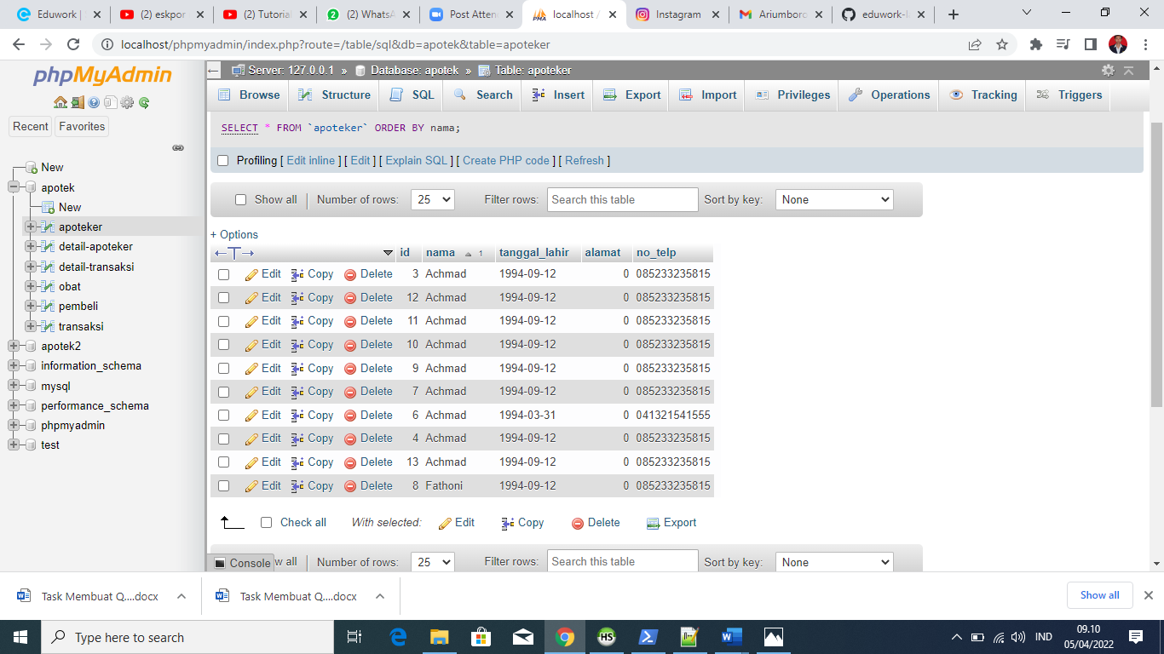

[SELECT](http://localhost/phpmyadmin/url.php?url=https://dev.mysql.com/doc/refman/8.0/en/select.html) nama FROM `apoteker`;

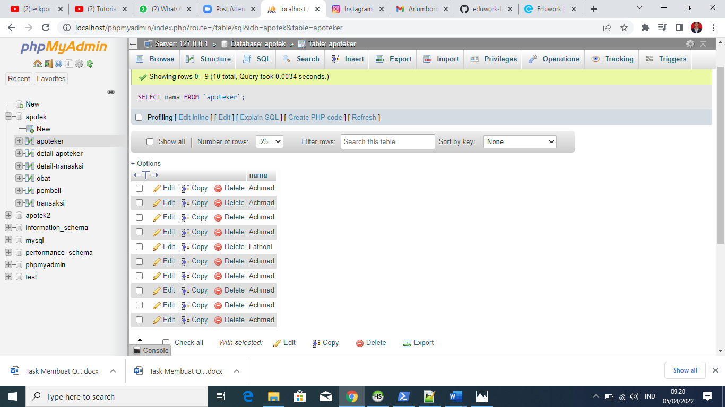

[SELECT](http://localhost/phpmyadmin/url.php?url=https://dev.mysql.com/doc/refman/8.0/en/select.html) nama, no_telp FROM `apoteker`;

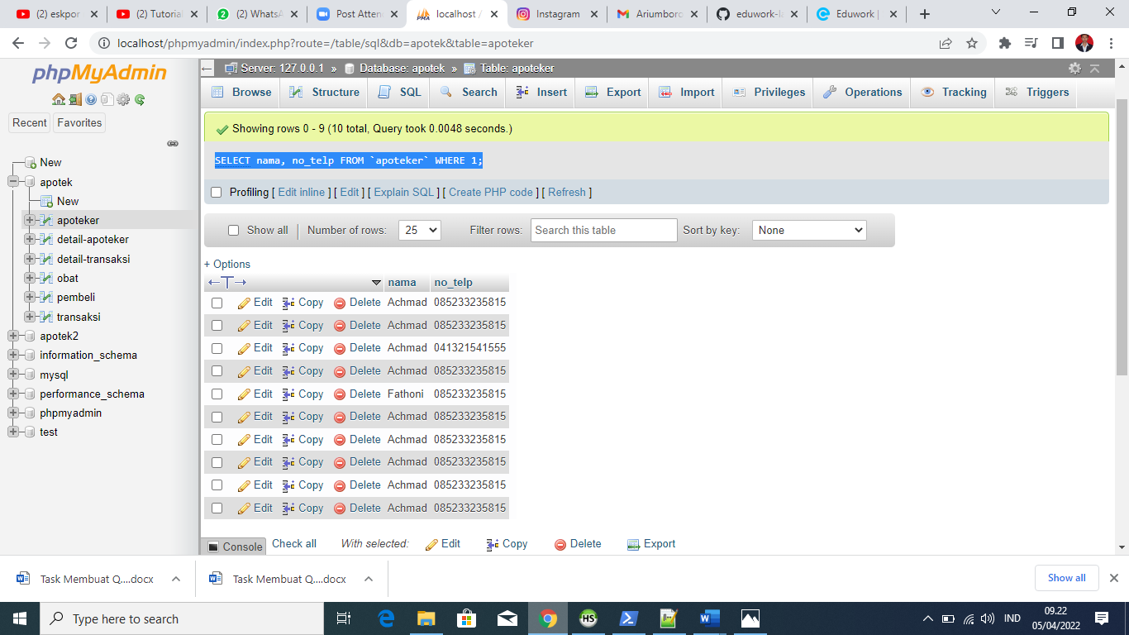

[SELECT](http://localhost/phpmyadmin/url.php?url=https://dev.mysql.com/doc/refman/8.0/en/select.html) * FROM `obat`;

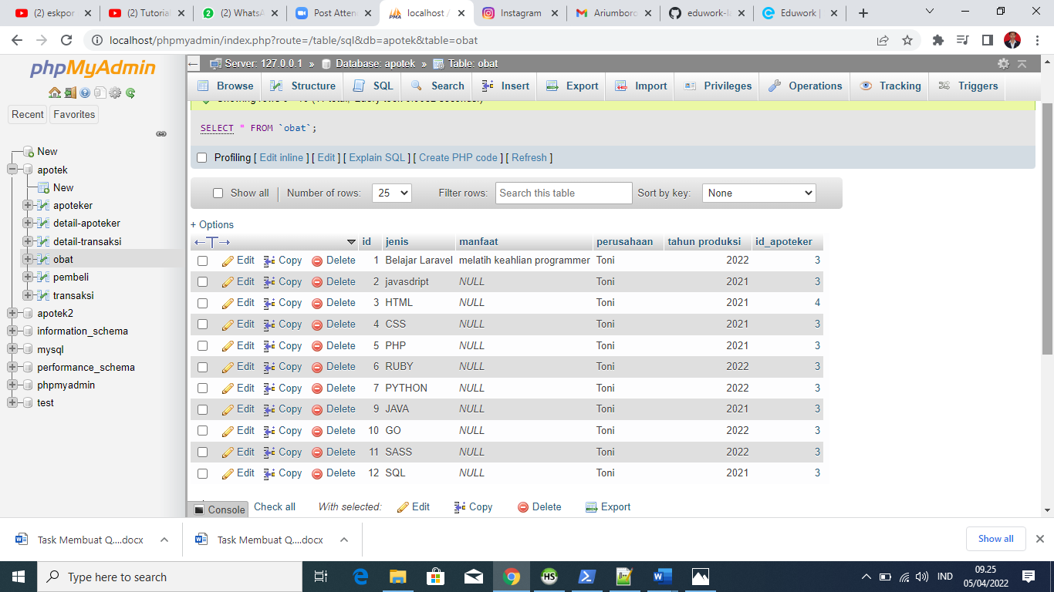

[SELECT](http://localhost/phpmyadmin/url.php?url=https://dev.mysql.com/doc/refman/8.0/en/select.html) jenis,manfaat FROM `obat`;

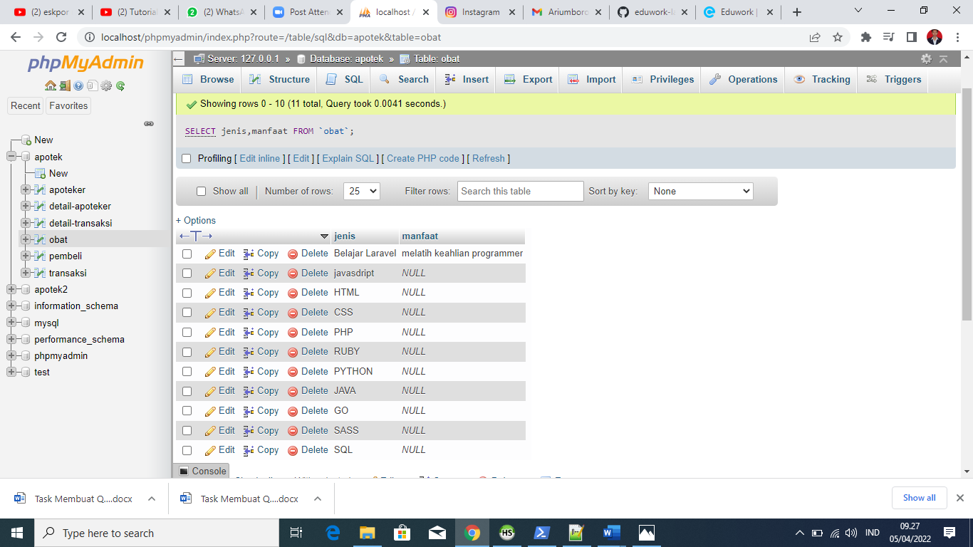

[SELECT](http://localhost/phpmyadmin/url.php?url=https://dev.mysql.com/doc/refman/8.0/en/select.html) domisili, agama, email, facebook, instragram FROM `detail-apoteker`;

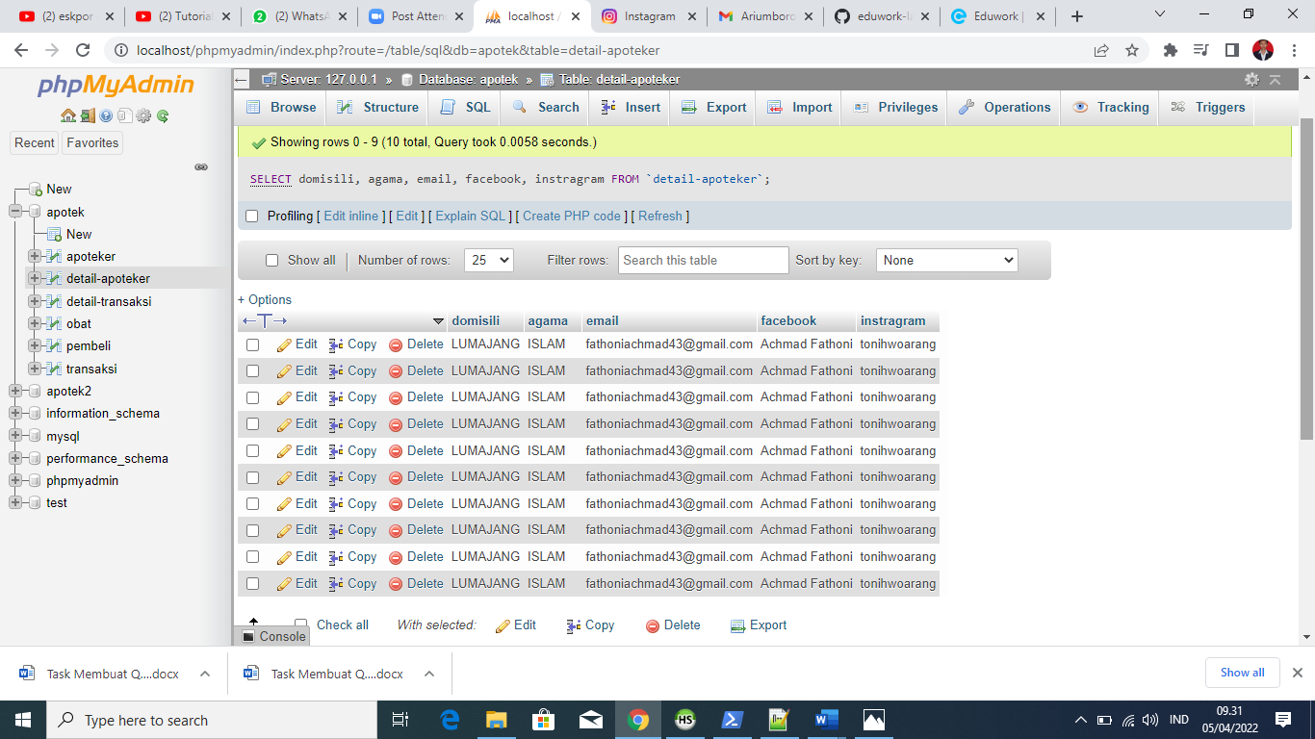

[SELECT](http://localhost/phpmyadmin/url.php?url=https://dev.mysql.com/doc/refman/8.0/en/select.html) * FROM `detail-apoteker`;

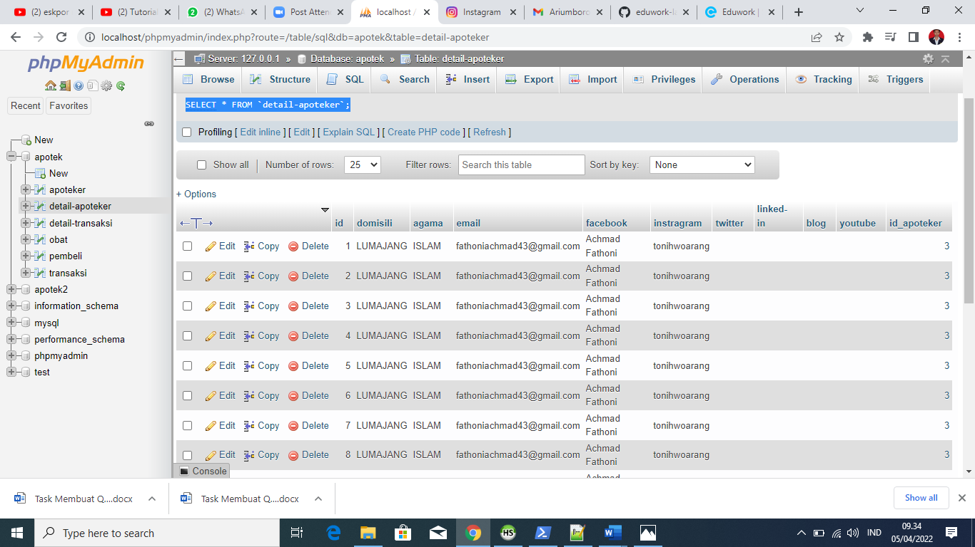

[SELECT](http://localhost/phpmyadmin/url.php?url=https://dev.mysql.com/doc/refman/8.0/en/select.html) * FROM `pembeli`

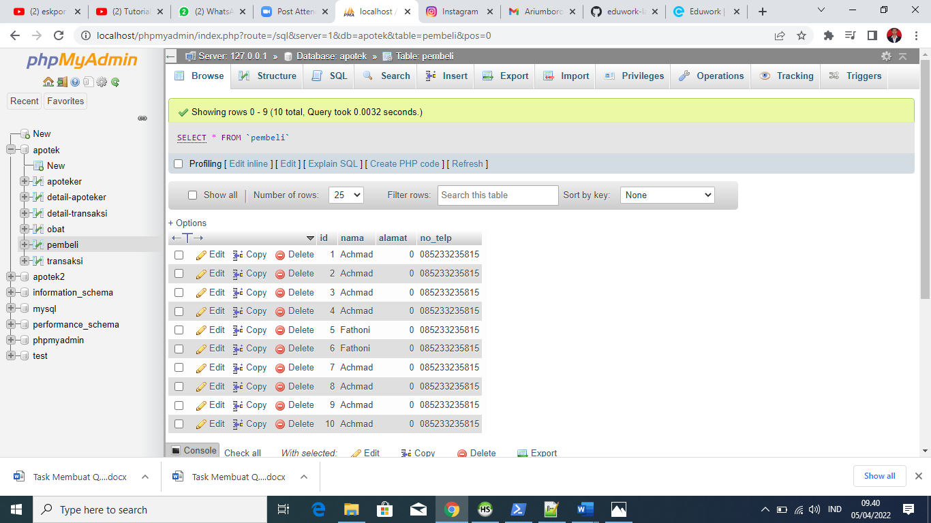

[SELECT](http://localhost/phpmyadmin/url.php?url=https://dev.mysql.com/doc/refman/8.0/en/select.html) nama, no_telp FROM `pembeli`;

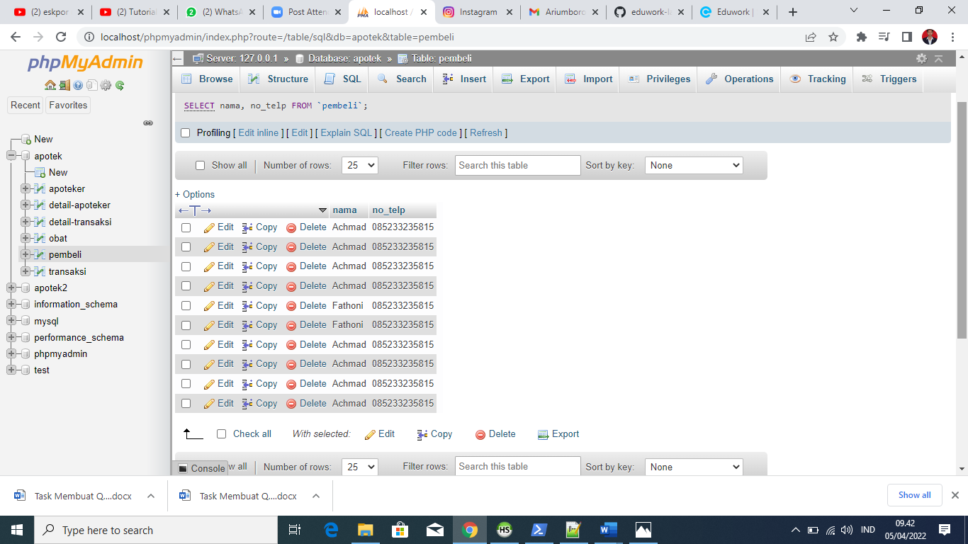

[SELECT](http://localhost/phpmyadmin/url.php?url=https://dev.mysql.com/doc/refman/8.0/en/select.html) * FROM `transaksi`

